PAMPLET

NAME : CHUNDURU DHEERAJ

PRODUCT : neural network(Laptop)

DATE : 3-03-2026

DESCRIPTION :

A movement-prediction neural network is a learning model that learns patterns from a user’s past actions (such as mouse movement, gestures, walking paths, or touch input) and uses those patterns to predict the user’s next movement.
Procedure:
Step1:
Movement collection:
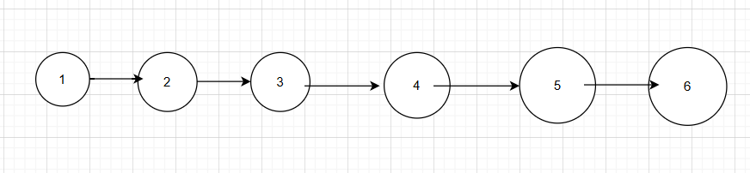
Step by movement it collect movement and form single layer network
Numbers represent mouse movement, keyboard movements)
Step2 : New collection:
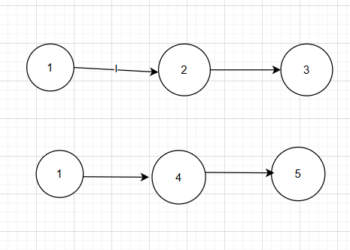

COMAPRE STEP1 AND STEP2:

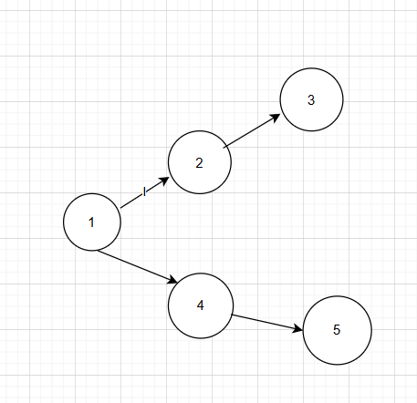
Step4:
Between 1 and 2 there is Activation energy and between 1 and 4 there is a activation energy
1 --->0.25---> 2
- ---> 0.5 ---> 4
0.25,0.5……. there are activation energy
After the position 1 it selects position 4

ACCORDING TO THAT NEURAL NETWORK EXPANDS
%3CmxGraphModel%3E%3Croot%3E%3CmxCell%20id%3D%220%22%2F%3E%3CmxCell%20id%3D%221%22%20parent%3D%220%22%2F%3E%3CmxCell%20id%3D%222%22%20parent%3D%221%22%20style%3D%22ellipse%3BwhiteSpace%3Dwrap%3Bhtml%3D1%3Baspect%3Dfixed%3B%22%20value%3D%221%22%20vertex%3D%221%22%3E%3CmxGeometry%20height%3D%2250%22%20width%3D%2250%22%20x%3D%2270%22%20y%3D%22200%22%20as%3D%22geometry%22%2F%3E%3C%2FmxCell%3E%3CmxCell%20id%3D%223%22%20parent%3D%221%22%20style%3D%22ellipse%3BwhiteSpace%3Dwrap%3Bhtml%3D1%3Baspect%3Dfixed%3B%22%20value%3D%222%22%20vertex%3D%221%22%3E%3CmxGeometry%20height%3D%2255%22%20width%3D%2255%22%20x%3D%22165%22%20y%3D%22200%22%20as%3D%22geometry%22%2F%3E%3C%2FmxCell%3E%3CmxCell%20id%3D%224%22%20parent%3D%221%22%20style%3D%22ellipse%3BwhiteSpace%3Dwrap%3Bhtml%3D1%3Baspect%3Dfixed%3B%22%20value%3D%223%22%20vertex%3D%221%22%3E%3CmxGeometry%20height%3D%2255%22%20width%3D%2255%22%20x%3D%22270%22%20y%3D%22200%22%20as%3D%22geometry%22%2F%3E%3C%2FmxCell%3E%3CmxCell%20id%3D%225%22%20parent%3D%221%22%20style%3D%22ellipse%3BwhiteSpace%3Dwrap%3Bhtml%3D1%3Baspect%3Dfixed%3B%22%20value%3D%224%22%20vertex%3D%221%22%3E%3CmxGeometry%20height%3D%2261.25%22%20width%3D%2261.25%22%20x%3D%22394%22%20y%3D%22200%22%20as%3D%22geometry%22%2F%3E%3C%2FmxCell%3E%3CmxCell%20id%3D%226%22%20parent%3D%221%22%20style%3D%22ellipse%3BwhiteSpace%3Dwrap%3Bhtml%3D1%3Baspect%3Dfixed%3B%22%20value%3D%225%22%20vertex%3D%221%22%3E%3CmxGeometry%20height%3D%2270.63%22%20width%3D%2270.63%22%20x%3D%22520%22%20y%3D%22195.31%22%20as%3D%22geometry%22%2F%3E%3C%2FmxCell%3E%3CmxCell%20id%3D%227%22%20parent%3D%221%22%20style%3D%22ellipse%3BwhiteSpace%3Dwrap%3Bhtml%3D1%3Baspect%3Dfixed%3B%22%20value%3D%226%22%20vertex%3D%221%22%3E%3CmxGeometry%20height%3D%2272.66%22%20width%3D%2272.66%22%20x%3D%22640%22%20y%3D%22195.31%22%20as%3D%22geometry%22%2F%3E%3C%2FmxCell%3E%3CmxCell%20id%3D%228%22%20edge%3D%221%22%20parent%3D%221%22%20style%3D%22endArrow%3Dclassic%3Bhtml%3D1%3Brounded%3D0%3B%22%20value%3D%22%22%3E%3CmxGeometry%20height%3D%2250%22%20relative%3D%221%22%20width%3D%2250%22%20as%3D%22geometry%22%3E%3CArray%20as%3D%22points%22%3E%3CmxPoint%20x%3D%22140%22%20y%3D%22224.5%22%2F%3E%3C%2FArray%3E%3CmxPoint%20x%3D%22120%22%20y%3D%22224.5%22%20as%3D%22sourcePoint%22%2F%3E%3CmxPoint%20x%3D%22170%22%20y%3D%22224.5%22%20as%3D%22targetPoint%22%2F%3E%3C%2FmxGeometry%3E%3C%2FmxCell%3E%3CmxCell%20id%3D%229%22%20edge%3D%221%22%20parent%3D%221%22%20style%3D%22endArrow%3Dclassic%3Bhtml%3D1%3Brounded%3D0%3B%22%20value%3D%22%22%3E%3CmxGeometry%20height%3D%2250%22%20relative%3D%221%22%20width%3D%2250%22%20as%3D%22geometry%22%3E%3CmxPoint%20x%3D%22220%22%20y%3D%22227%22%20as%3D%22sourcePoint%22%2F%3E%3CmxPoint%20x%3D%22270%22%20y%3D%22227%22%20as%3D%22targetPoint%22%2F%3E%3C%2FmxGeometry%3E%3C%2FmxCell%3E%3CmxCell%20id%3D%2210%22%20edge%3D%221%22%20parent%3D%221%22%20style%3D%22endArrow%3Dclassic%3Bhtml%3D1%3Brounded%3D0%3B%22%20value%3D%22%22%3E%3CmxGeometry%20height%3D%2250%22%20relative%3D%221%22%20width%3D%2250%22%20as%3D%22geometry%22%3E%3CmxPoint%20x%3D%22320%22%20y%3D%22231.15%22%20as%3D%22sourcePoint%22%2F%3E%3CmxPoint%20x%3D%22390%22%20y%3D%22231.15%22%20as%3D%22targetPoint%22%2F%3E%3C%2FmxGeometry%3E%3C%2FmxCell%3E%3CmxCell%20id%3D%2211%22%20edge%3D%221%22%20parent%3D%221%22%20style%3D%22endArrow%3Dclassic%3Bhtml%3D1%3Brounded%3D0%3B%22%20value%3D%22%22%3E%3CmxGeometry%20height%3D%2250%22%20relative%3D%221%22%20width%3D%2250%22%20as%3D%22geometry%22%3E%3CmxPoint%20x%3D%22440%22%20y%3D%22231.14%22%20as%3D%22sourcePoint%22%2F%3E%3CmxPoint%20x%3D%22520%22%20y%3D%22231.14%22%20as%3D%22targetPoint%22%2F%3E%3C%2FmxGeometry%3E%3C%2FmxCell%3E%3CmxCell%20id%3D%2212%22%20edge%3D%221%22%20parent%3D%221%22%20style%3D%22endArrow%3Dclassic%3Bhtml%3D1%3Brounded%3D0%3B%22%20value%3D%22%22%3E%3CmxGeometry%20height%3D%2250%22%20relative%3D%221%22%20width%3D%2250%22%20as%3D%22geometry%22%3E%3CmxPoint%20x%3D%22580%22%20y%3D%22230.13%22%20as%3D%22sourcePoint%22%2F%3E%3CmxPoint%20x%3D%22650%22%20y%3D%22230.13%22%20as%3D%22targetPoint%22%2F%3E%3C%2FmxGeometry%3E%3C%2FmxCell%3E%3C%2Froot%3E%3C%2FmxGraphModel%3

